Netflix Data-Cleaning, Analysis and Visualization

Overview

The Netflix Story project is a data analysis and visualization project that focuses on examining and presenting insights from Netflix-related data. The dataset used for this project can be found on Kaggle.com and provides valuable information about Netflix content.

The primary goal of this project is to leverage Tableau to explore, analyze, and visualize the dataset. By doing so, we aim to uncover trends, patterns, and interesting insights related to Netflix's content library, viewership, and more.

Dataset

The dataset for this project can be obtained from Kaggle.com. It contains comprehensive information about Netflix titles, including details like title, type (movie or TV show), release year, country, duration, and more. The dataset is crucial for conducting in-depth analyses and creating informative visualizations.

Project Components

1. Data Exploration and Cleaning

Before diving into data visualization, we'll perform data exploration and cleaning. This step involves:

* Handling missing or inconsistent data.
* Exploring the dataset's structure.
* Identifying any outliers or anomalies.

2. Tableau Visualization

The core of this project lies in using Tableau to create compelling visualizations.

3. Documentation

A well-documented project is essential for sharing insights and findings. We'll prepare documentation that includes:

* A brief project overview.
* Details of the dataset used.
* Explanation of Tableau visualizations and their significance.
* Insights and observations from the analysis.

Top 10 most watched genres in the dataset

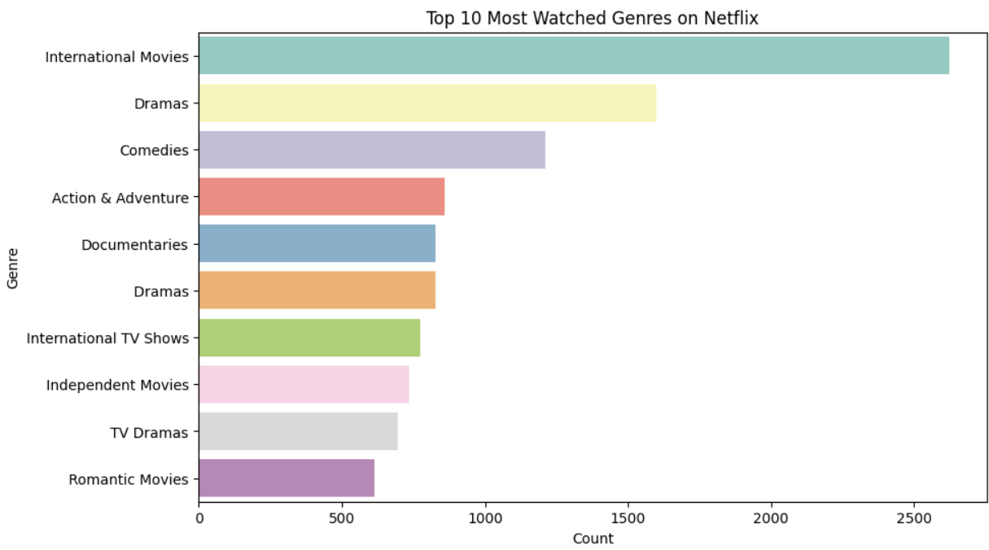

Content Added Over The Time

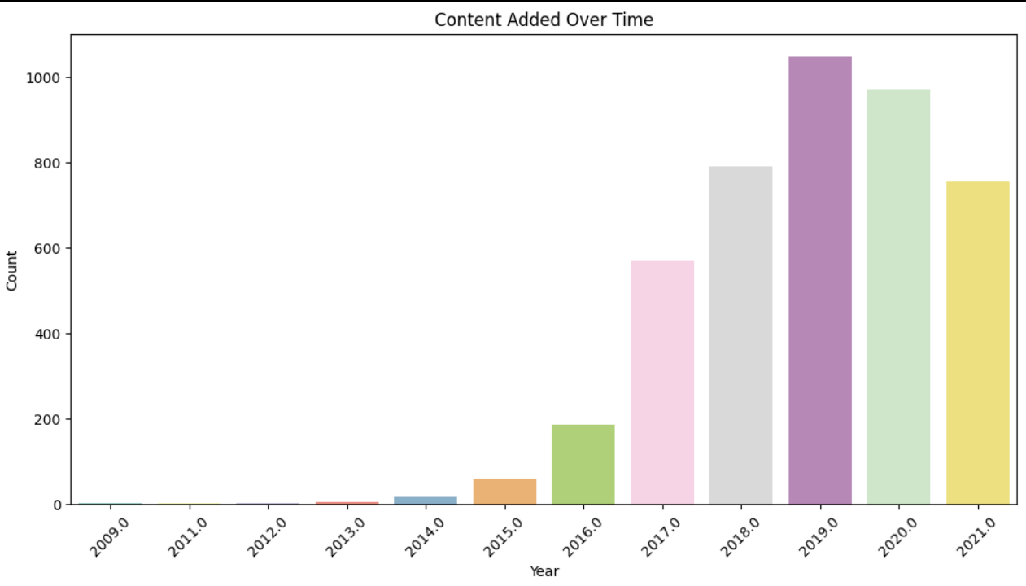

**Top 10 Directors with the Most Titles**

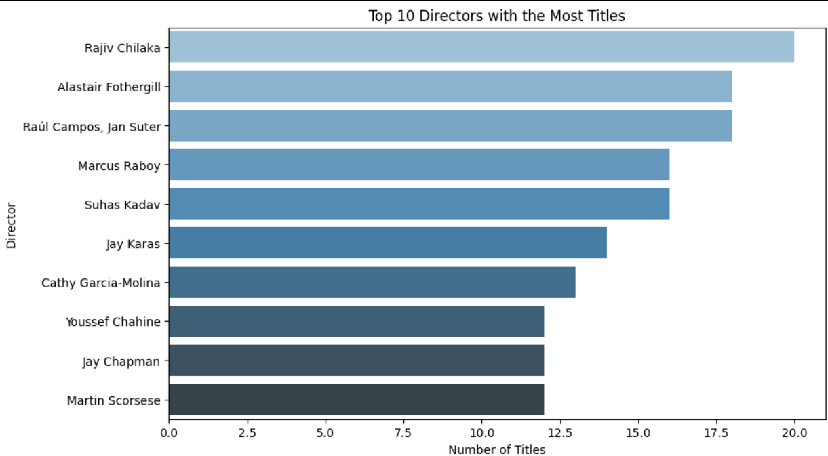

**Word Cloud of Movie Titles**

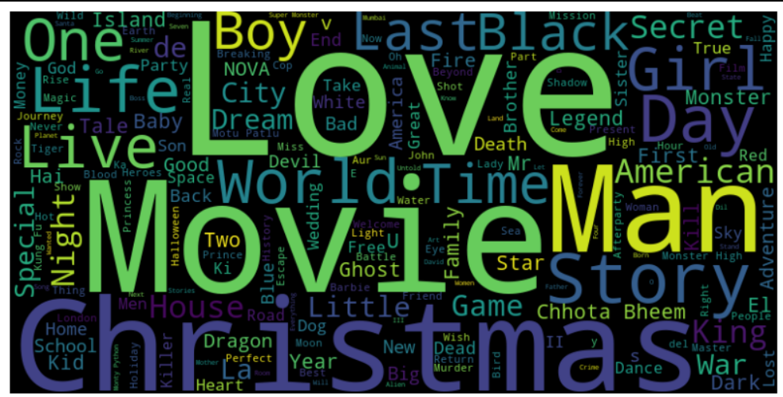

Content distribution on Netflix

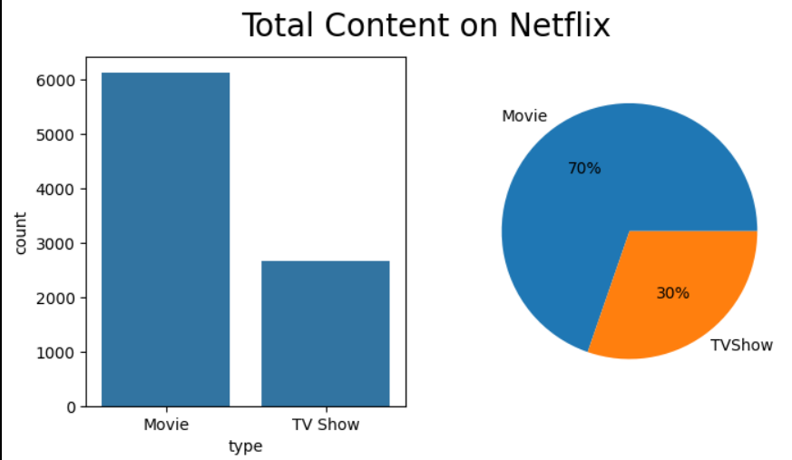

Rating frequency of movies & TV Shows on Netflix.

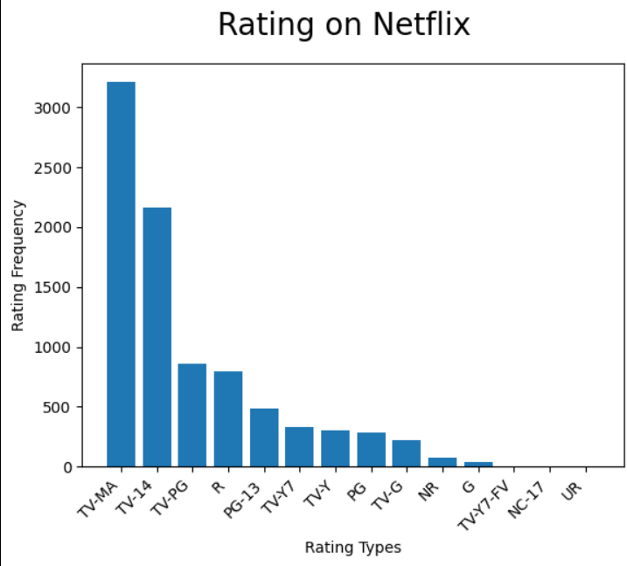

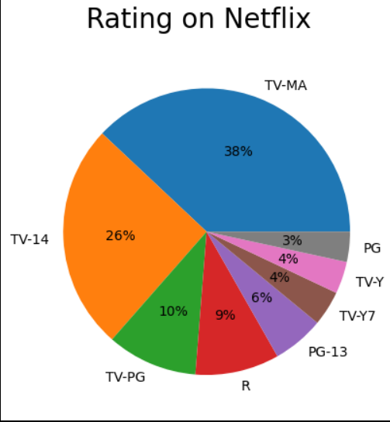

Monthly releases of Movies and TV shows on Netflix

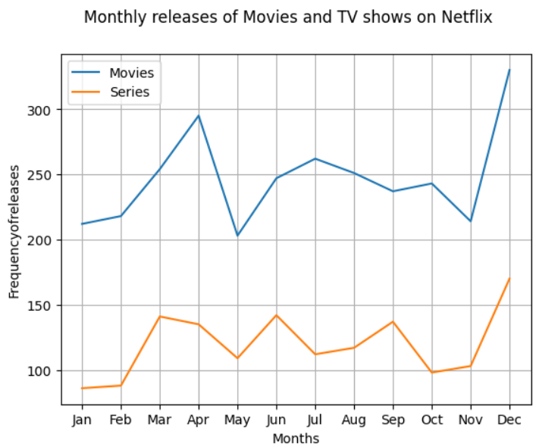

Yearly releases of Movies and TV Shows on Netflix

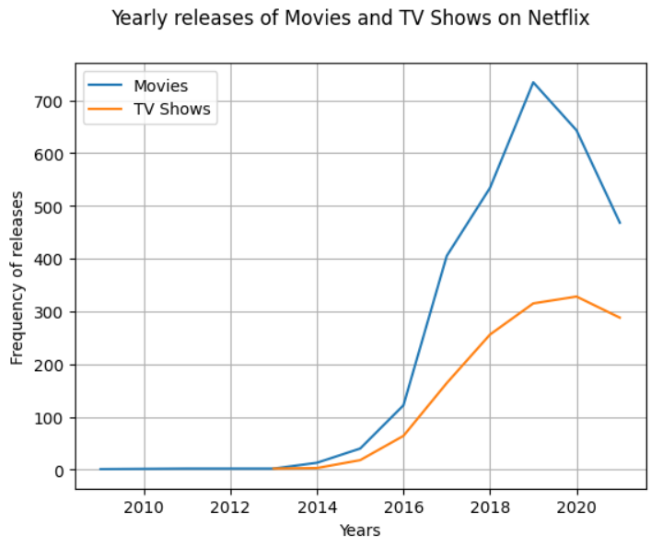

Top 10 popular movie genres

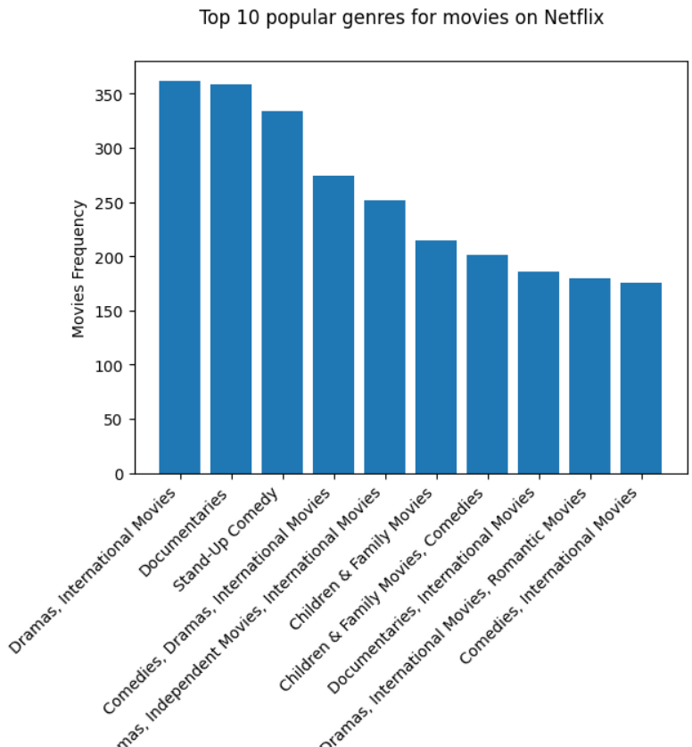

Top 15 directors across Netflix with high frequency of movies and shows

